Javier Jesús Macossay-Hernández EE 348L

March 25, 2016

**Prelab #6**

Exercise 1

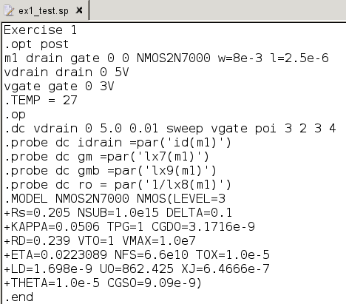

Netlist

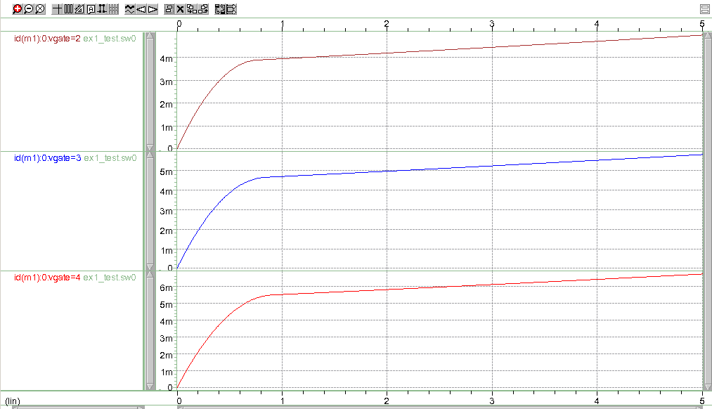

Current through MOSFET

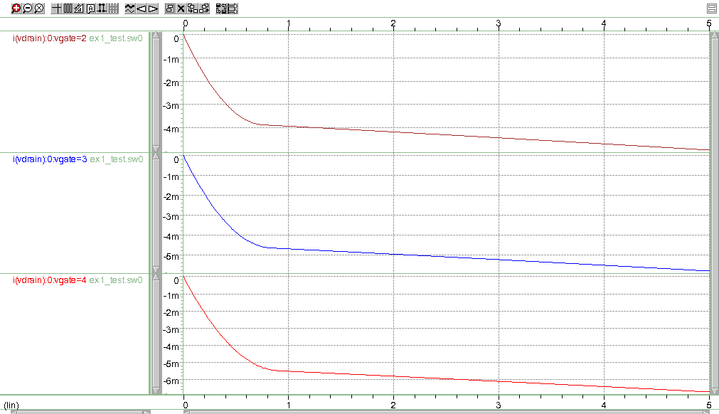

Current through the Drain

Exercise 2

|  |  |  |
| --- | --- | --- |
| Vg | Id | Gm |
| 0 | 0.00364 | 0 |
| 0.25 | 0.00228 | -0.00543 |
| 0.5 | 0.00124 | -0.00417 |
| 0.75 | 0.00051 | -0.00290 |
| 1 | 0.00010 | -0.00164 |
| 1.25 | 0.00001 | -0.00038 |
| 1.5 | 0.00023 | 0.00088 |
| 1.75 | 0.00076 | 0.00215 |
| 2 | 0.00162 | 0.00341 |
| 2.25 | 0.00278 | 0.00467 |
| 2.5 | 0.00427 | 0.00593 |
| 2.75 | 0.00607 | 0.00720 |
| 3 | 0.00818 | 0.00846 |
| 3.25 | 0.01061 | 0.00972 |
| 3.5 | 0.01336 | 0.01098 |
| 3.75 | 0.01642 | 0.01225 |
| 4 | 0.01980 | 0.01351 |
| 4.25 | 0.02349 | 0.01477 |
| 4.5 | 0.02750 | 0.01603 |
| 4.75 | 0.03182 | 0.01730 |
| 5 | 0.03646 | 0.01856 |

IDS vs. VGS

Transconductance vs. VGS

Exercise 3

|  |  |  |
| --- | --- | --- |
| Vg | Id | Gds |
| 0 | 0.00365 | 0 |
| 0.25 | 0.00229 | -0.00545025 |
| 0.5 | 0.00124 | -0.00418275 |
| 0.75 | 0.00051 | -0.00291525 |
| 1 | 0.00010 | -0.00164775 |
| 1.25 | 0.00001 | -0.00038025 |
| 1.5 | 0.00023 | 0.00088725 |
| 1.75 | 0.00077 | 0.00215475 |
| 2 | 0.00162 | 0.00342225 |
| 2.25 | 0.00279 | 0.00468975 |
| 2.5 | 0.00428 | 0.00595725 |
| 2.75 | 0.00609 | 0.00722475 |
| 3 | 0.00821 | 0.00849225 |
| 3.25 | 0.01065 | 0.00975975 |
| 3.5 | 0.01341 | 0.01102725 |
| 3.75 | 0.01648 | 0.01229475 |
| 4 | 0.01987 | 0.01356225 |
| 4.25 | 0.02358 | 0.01482975 |
| 4.5 | 0.02761 | 0.01609725 |
| 4.75 | 0.03195 | 0.01736475 |
| 5 | 0.03661 | 0.01863225 |

IDS vs. VGS

|  |  |
| --- | --- |
| Vg | Ro |
| 0 | 0 |
| 0.25 | 0 |
| 0.5 | 0 |
| 0.75 | 0 |
| 1 | 0 |
| 1.25 | 0 |
| 1.5 | 1127.07805 |
| 1.75 | 464.0909618 |
| 2 | 292.2054204 |
| 2.25 | 213.2309825 |
| 2.5 | 167.8626883 |
| 2.75 | 138.4130939 |
| 3 | 117.7544232 |
| 3.25 | 102.4616409 |
| 3.5 | 90.68444082 |
| 3.75 | 81.33552939 |
| 4 | 73.73407805 |
| 4.25 | 67.43202009 |
| 4.5 | 62.12241221 |
| 4.75 | 57.58792957 |
| 5 | 53.67038334 |

Output Resistance of the Transistor vs. VGS

Exercise 4

|  |  |
| --- | --- |
| Vg | Intrinsic Gain |
| 0 | 0 |
| 0.25 | 0 |
| 0.5 | 0 |
| 0.75 | 0 |
| 1 | 0 |
| 1.25 | 0 |
| 1.5 | 0.996055227 |
| 1.75 | 0.996055227 |
| 2 | 0.996055227 |
| 2.25 | 0.996055227 |
| 2.5 | 0.996055227 |
| 2.75 | 0.996055227 |
| 3 | 0.996055227 |
| 3.25 | 0.996055227 |
| 3.5 | 0.996055227 |
| 3.75 | 0.996055227 |
| 4 | 0.996055227 |
| 4.25 | 0.996055227 |
| 4.5 | 0.996055227 |
| 4.75 | 0.996055227 |
| 5 | 0.996055227 |

Intrinsic Gain vs. VGS

Exercise 5

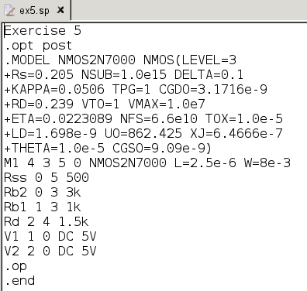

Netlist

The current through the resistor is within the ±2%. (Node 2 – Node 4)/Rd = (5 – 3.47)/1.5k = 1.02 mA. As seen in the output file below. The VG required is 3.75 V.

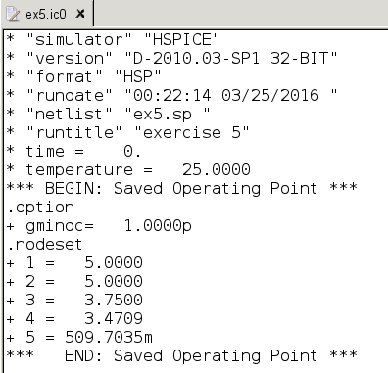

Output File

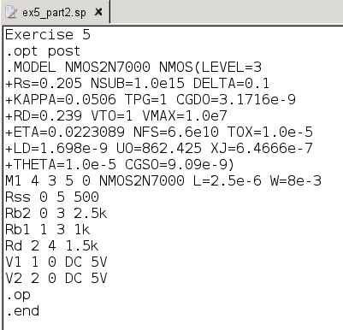

Netlist

The current through the resistor is within the ±2%. (Node 2 – Node 4)/Rd = (5 – 3.49)/1.5k = 1 mA. As seen in the output file below. The VG required is 3.57 V.

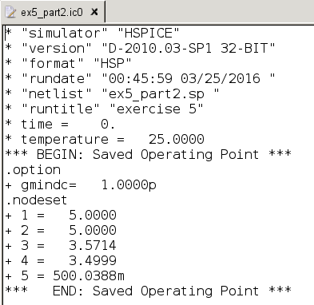

Output File